Dear Martin,

Thank you again for the chapter on gaze. This is really fabulous, extremely useful, and I found it beautifully written right up until the end (which you claim not to have edited). I have a few comments but these are quite possibly the largely irrelevant musing of a philosopher that aren’t really relevant to the book project. I’ll impose them on you nevertheless because I’m sure this will help in thinking through what we might do together on engagement.
There’re loads of points where I think ‘that’s a really useful point’ or ‘that’s nicely put’ but I won’t mention them here except to say that the possibility of the ‘highly visible eye’ idea as an alternative to nativism came across very forcefully and is beautifully put (p. 21).
Here’s my main request. As I read it, two key themes in the chapter are (i) how engagement and gaze following relate, and (ii) how gaze following relates to judgements about gaze. I think you need to identify and distinguish these themes more clearly; readers might find it hard to keep them apart. For example, on p. 31 you shift from gaze following to judgements and simultaneously from other cues of engagement to gaze as a cue of engagement. It’s maybe worth mentioning the double shift explicitly.
Of course you could simply make the distinction between themes (i) and (ii) more explicit. But it would be even better to say a bit more about how these relate in your overview section; you already give the reader most of the materials to assemble this, but it’s quite difficult to do. So you might say, for example, that (a) level 1 perspective taking relates to engagement which relates to gaze following; and (b) level 2 perspective taking relates to false belief (p. 34) which relates to explicit judgements about gaze direction. Although there are some nice hints I’m not sure exactly how you want to relate these things together and it would be great to have more on this. Of course, I realise this is an entirely selfish request rather than something that a general book obviously needs.
On p. 15 last paragraph, the first and last sentences are hard to reconcile: you say that it’s consistent with the findings to suppose that chimps are only sensitive to who is facing where, then that Hare has found “sensitivity to what another has seen” (which seems to involve more than sensitivity to where someone is facing). There’s also a rogue ‘T’ at the end of this paragraph.
On pp. 15–6 you have a paragraph on Povinelli and Vonk’s it-might-all-be-behavioural-rules position. I think you give too much prominence to this idea. It’s not justified by any serious experimental work and as far as I can tell it’s simply a failure of imagination on their part in trying to explain what Chimps can and can’t do. The challenge is a not a good one because (i) it’s completely generic—you can make a similar challenge almost anywhere, (ii) there’s no good reason for supposing that the ‘behavioural rules’ hypothesis provides a better explanation than the alternatives, (iii) Josep Call has shown that in general chimps are typically very bad at learning arbitrary rules. Also the experiment they suggest seems bizarre. In short, I don’t accept that Povinelli and Vonk offer a genuine alternative to the Hare view you describe, although I do accept that the Hare view is in a bit of a flux and not entirely well defended.
On p. 16 you say Chimps can make use of “visual perspective” and can take into account “visual access”. This sounds stronger than you intended. They don’t seem to have any understanding of vision as such, so the most that could be said here is “perceptual access”. Later in this paragraph you say Chimps are sensitive to “global perceptual access”. I read this as expressing agreement with the Hare view, according to which chimps are sensitive to bodily orientation as an indicator of perceptual access, and disagreeing with the Povinelli view, according to which chimps are sensitive to bodily orientation as something reliably linked to behaviour via a set of rules. I’m not sure whether you want to be read as agreeing with the Hare view.
On p. 17 you talk about “the relation between perception and behaviour” and there being no “intervening ‘mind’”. I think this is a bit misleading: perception is a mental state so to think of perception as controlling behaviour involves thinking of there being a mind mediating between environment and behaviour.
The case of the experimenter talking to the puppets on p. 19 is very interesting. I read you as saying that talking makes infants better able to follow gaze, but I suppose it’s also possible that infants look at what someone is talking to rather than follow gaze.
On p. 22 the last sentence of the paragraph about Woodward, “All three age groups …”, seems to conflict with Corkum and Moore’s findings. Is there a conflict and if so do you accept Woodward or C&M’s view or are you neutral?
This is not at all relevant to the book project but the paragraph on gaze following through apertures is very interesting. Partly this is because I think there’s a really close relation between understanding perception and understand occlusion—perception is a causal concept, so one plausibly necessary condition for being able to think about perception as opposed to some more general kind of engagement would be an understanding of perceptual occlusion (i.e. things that block a causal chain linking perceiver to objects of perception). I also think the following-gaze-through-gappy-occuders is interesting in relation to Baillargeon on infants’ visual expectations about occlusion—according to her, infants already expect objects to appear in a range of gap types from 3.5 months, in which case there’s an interesting failure to relate understanding of ‘gappy occlusion’ to understanding of gaze.
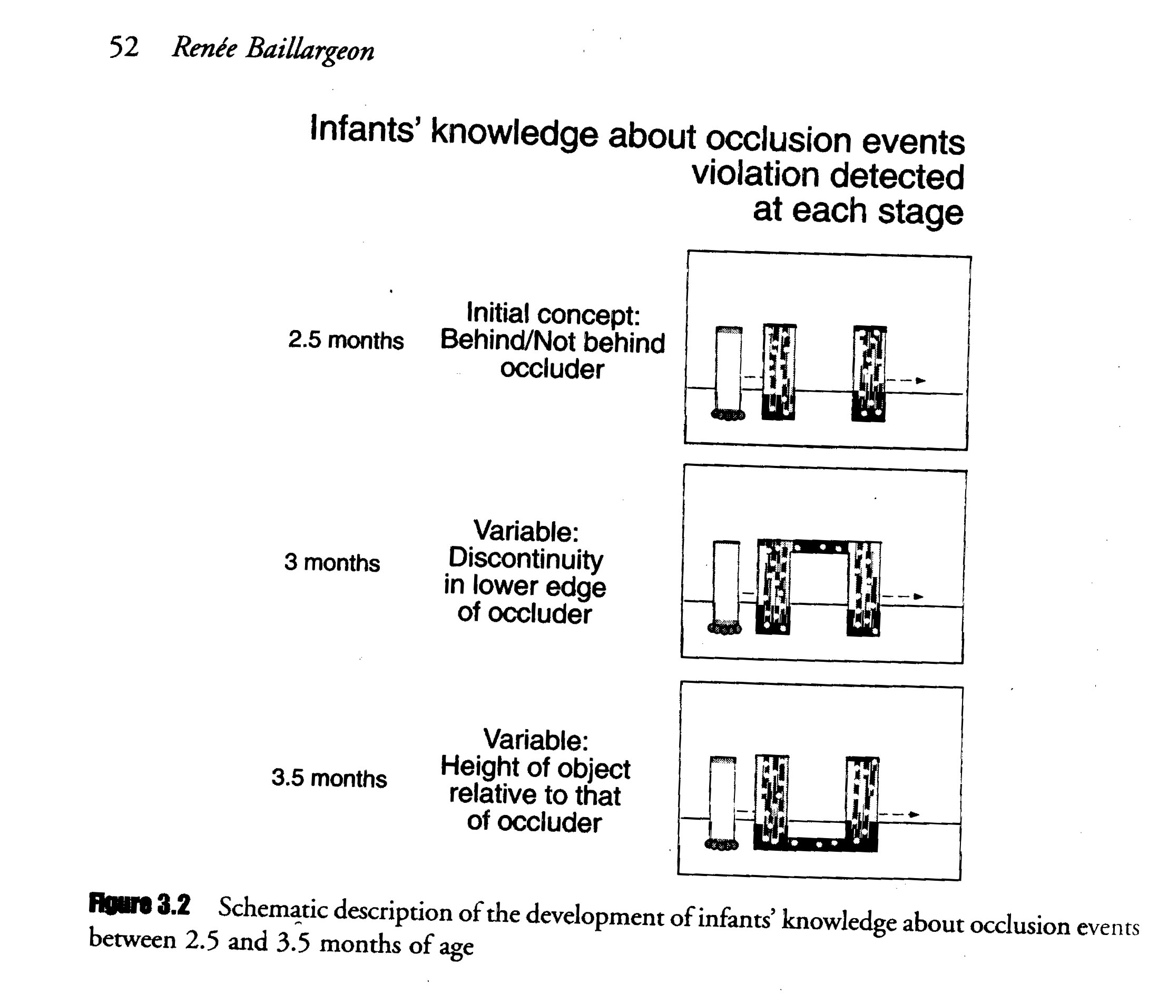
I’d like a better discussion of what it means to think of gaze as referential. You start discussing this (p. 23) but immediately shift to the different issue of nativism. I’d like some sense of what Butler might mean and how thinking of gaze as referential might be distinct from thinking of it non-referentially.
What is a “representational understanding of visual attention” (p. 25)?
You say (p. 30) that engagement is (i) rudimentary, (ii) non-mentalistic (also p. 35, “it does not imply an understanding of mental states”), and (iii) a concept of attention. None of these things are obviously true and they don’t appear to follow from what you said about it above. On (iii), you several times talk about younger children as understanding attention (e.g. p35) but it seems possible that attention always involves a particular mode, so it’s always perceptual attention or attending to something in thought, in which case being able to think about attention already presupposes being able to think about perception or thought.
On p. 35 you say “stop around here?” to which I’d say no way, you really should mention the gradual development of gaze judgements as an argument for distinct bases for the following and judging abilities. On the other hand I’m not sure what representational redescription is doing here; everyone cites it but no one explains what it is and as far as I can tell some people cite it without considering it as a serious possibility.
Anyway, these are just a few picky points that jumped out at me as I read the chapter. I learnt loads from reading this and found it very useful.

Best wishes,

Steve

